Group ? - ETL Project Proposal

Project Title: **“Fiscal Heartbreak”**

**Team Members:**

* Joseph Ayala
* Andrew Behrman
* Sean Findlay
* Michael Fox
* Michael Hankinson

**Project Description:** Our team will channel our inner-Freakanomic spirit to analyze the impact of US Fiscal Policy on US Family Households. More specifically, we will look at the trends of Consumer Debt by state as compared to the trends of Divorce Rates, Marriage Rates by state

**Preliminary Hypothesis:** *Higher levels of consumer debt lead to higher rates of divorce and lower rates of marriage.*

**Datasets to be Used:**

* *Marriage Stats -- Census.gov ACS data - table S1201:* [*https://factfinder.census.gov/faces/tableservices/jsf/pages/productview.xhtml?pid=ACS_17_1YR_S1201&prodType=table*](https://factfinder.census.gov/faces/tableservices/jsf/pages/productview.xhtml?pid=ACS_17_1YR_S1201&prodType=table)

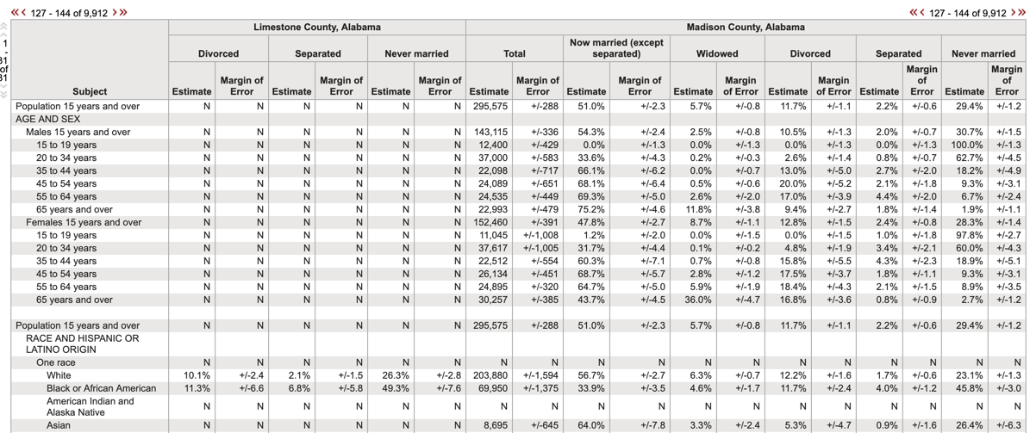

* *Debt to Income Ratios -- FederalReserve.gov:* [*https://www.federalreserve.gov/releases/z1/dataviz/household_debt/state/map/#year:2011*](https://www.federalreserve.gov/releases/z1/dataviz/household_debt/state/map/#year:2011)

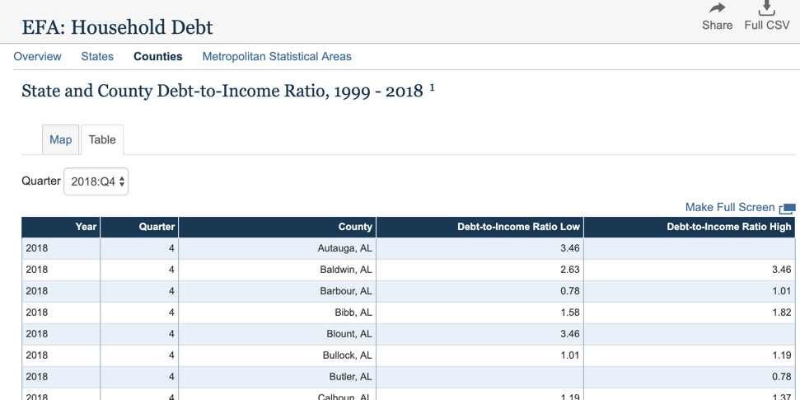

***Breakdown of Tasks****:*

|  |  |
| --- | --- |
| ***Task*** | ***Owner*** |
| *Target Data Model and Design* | ***Mike*** |
| *Extract and Transform Debt Data* | ***Joseph*** |
| *Extract and Transform Marriage Data* | ***Michael*** |
| *Database Load* | ***Sean*** |
| *Create sample database view* | ***Andrew*** |
| *Repository Admin* | ***Joseph*** |
| *Primary Document Owner* | ***Andrew*** |